Lisa Caron SDEV153 – Web Site Development with Professor Ruben 4/27/18

Final Website Project Report

# Topic/Background/Introduction

## Name of web site:

## Elite Custom Painting, Inc.

## Purpose/Mission (A paragraph statement is usually sufficient).

Purpose was to create a website for an employer/friend so he could advertise through social media, word of mouth, web searches and have a URL to put on business cards to hand out. This would enable him to have a modern source of contact to prove himself as an established/trustworthy/authentic and verifiable company.

## Goals:

## Objectives – (List all goals and objectives). Please note: This section is a *big deal*.

* Provide company services and contact info available on line
* Enable prospective clients to view different services available
* Allow prospective clients to contact company on-line directly
* Provide a modern web presence to reach out to former/current/future clients.

## Target audience:

* 18+
* Businesses
* Decorators
* Contractors
* Home Owners
* Restoration Company
* Real Estate Developers
* Maintenance Coordinators

# Problem Exploration

## Questions for the client:

Following page is a copy of actual file I gave to customer, and can also be found in documents of site map @ <https://bobbi.ivytech.edu/~lcaron1/M13webprojectFinalDraft/documents/QuestionsForSam.pdf>

**Elite Custom Painting, Inc. Website**

**Couple of Questions:**

Do you already have any the following…

Logo

Color Scheme Business Card

Do you already have any ideas for what you would like on your website?

Like colors, pictures, images, videos…

Things you would like to say about company or yourself…

(History, Experience, Qualifications, and/or areas you will travel to (just Michiana?)

**This is just a loose first draft of page ideas to put in your website…**

**Home**: need catchy graphics and write up to draw in potential clients

**About**: need at least a paragraph about company and/or owner.

**Contact**: (How do you want clients to contact you?) Company: Elite Custom Painting, Inc.

Owner: Samuel Clark

Phone: (574) 299-7198

Email:

Address: (This might not be a good idea if you do not have a P.O. Box) Elite Custom Painting, Inc.

18732 New Rd

Bremen, Indiana 46616

**Services**: (not sure what to include or how you would like to word all this)

Painting

Varnishing Restoration

Spray Painting Drywall Finish Power Washing Interior/Exterior

Commercial/Industrial/Institutional/Governmental/Residential

**Testimonials**:

Of former clients or people/businesses you have worked with, or maybe make some up.

## What are the benchmarks or criteria to determine whether or not the site is “successful”?

All goals achieved. All navigations function as intended and required. Provide necessary information. Hope owner of company will like and become referral for successful web design work accomplished.

## Issues that have a technical impact such as bandwidth - NA

## Scope of the web site:

## Total pages: 16 HTML, 5 documents, 1 robots.txt, 3 JS, 3 CSS, 50+ images

## Levels: 3

## Page complexity: * please see section 4b of this document

## Multimedia: One link to YouTube video

## Assumptions and areas that may have to be changed later

I assumed images would illustrate type of work provided by a painting company, but some pages could use more information about company and owner such as in the About Us page.

## Site accessibility needs and implementation

Need an internet connection, browser enabled JavaScript and ability to use navigation.

# Requirements Analysis and Specification

## Goal details achieved

* + - Browsers tested under and supported.

Firefox, Google Chrome, Internet Explorer, Microsoft Edge

* + - Features or designs to support this goal.

Many visual images illustrating ideas a customer would want/need from a paint company.

Name, phone number, email address, physical address and a form provided to contact company.

* + - Other features or niceties (that are better listed here).
    - Physical Environment

At the moment the site is located in the bobbi.ivytech.edu server.

Maintained by ivytech staff and students I guess.

Not sure what customer will want for the future.

* + - Software Infrastructure - Static
    - Server software/hardware - no problems encountered to consider for this project.
    - Client software/hardware considerations

Haven’t had those conversations with customer yet. But he will need to find a server in future.

# Information Architecture, Organization, and Design

## Site genre, background, problems, and solutions.

* Genre: services industry
* Background: A (very small) privately owned painting company, that runs out of home of residence.
* Problems: No input from company owner except that he liked the idea of having a website.

Difficult to show a Paint Company with no images provided or info for pages like About Us

* Solutions: I designed the site independently.

Found images of work a paint company does in pexels.com that are

“Free for personal and commercial use” and “No attribution required

## Discuss the topology—the pages and how they are connected.

* All pages connect to the site map in the footer area. Site map connects to all sites and documents
* All pages have a navigation bar that connects to
  + 2 external sites for and local weather and directions
  + 4 main html pages… (Home, About Us, Contact Us & Services)

|  |  |  |
| --- | --- | --- |
| **Pages in Navigation Bar** | **Connect to…** | **Connect to…** |
| Home |  |  |
| About Us |  |  |
| Services | Interior | Painting |
|  |  | Restoration |
|  |  | Wood Finishing |
|  |  | Drywall Finishing |
|  |  | Residential/Commercial |
|  | Exterior | Painting |
|  |  | Restoration |
|  |  | Wood Finishing |
|  |  | Power Washing |
|  |  | Residential/Commercial |
|  | Painting | Interiors |
|  |  | Exteriors |
|  |  | Restoration |
|  |  | Wood Finishing |
|  |  | Residential/Commercial |
|  | External Site | YouTube.com |
| Contact Us | Results Page |  |
| Local Weather | External Site | Weather.com |
| Directions | External Site | Google.com/maps |
| **Page In Footer** |  |  |
| Site Map | All Sites & Documents |  |
|  | Documents File | Initial Project Plan (projectplan.html) |
|  |  | Loose outline and first Questions for client (PDF) |
|  |  | Project Requirements (PDF) |
|  |  | Web Requirements with Specifications 1 (PDF) |
|  |  | Project Report (PDF) |
|  |  |  |

## Refer to your attached mockup of the graphic layout to provide an explanation of or reference to your “template”.

Was never asked to design a mockup of graphic layout or template.

But I did initially model my site using Unit F homework in course. The 1st draft can be found at

<https://bobbi.ivytech.edu/~lcaron1/PROJECT/M07webprojectFirstDraft/index.html>

## Mention competing ideas that you had to resolve.

What the heck to do with the only images I had to work with (they shown are on the next page). One from a picture I took with my cell phone of a sign from his yard at his birthday party, and the other I stole from his Facebook page of his new car that he loves.

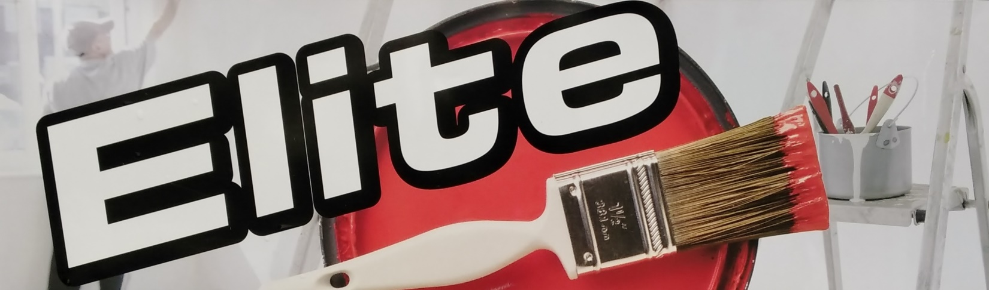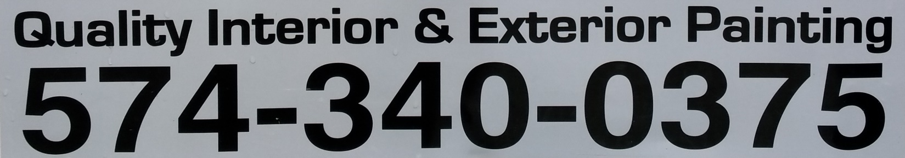

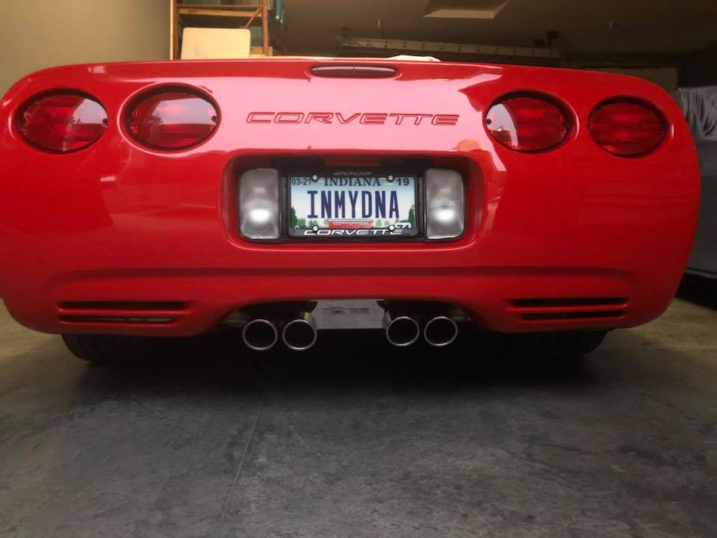

# Testing, Maintenance, and Promotion Plan

## Review – Find a few people who are unfamiliar with your web site and document their reactions and comments.

My son thinks we should run around and take pictures of buildings/ homes/churches/apartments/etc. that was actually worked on, instead of “borrowing” images of similar work from internet.

(He has no idea the time it would take to contact people and arrange times, take photos, and then edit.)

My client Sam recently texted - “That’s really cool!! I like that a lot:)”

But he is too busy to need it now – probably wait for fall to put it up.

My client’s wife Stacy recently emailed – “He has been so busy, but I think it is coming along great! He will too, he’s not to techy, but this is a nice feature to have for every business! Thank you!”

## Updating

Unknown at this time – depends on what the owner of company wants/needs in the future and current site location on the bobbi.ivytech.edu server goes dark 90 days after end of semester so I’m not sure.

## “Advertising” and promotion (gaining traffic).

Web site url may be included on new business cards that will be handed out. Maybe Facebook.

## Search engine submission. Address search engine issues, i.e., metadata,

Not submitted yet. Waiting for approval from customer.

# Implementation and Reflection

## Resources—informal bibliography, links, other references.

<https://www.pexels.com/>

For images used that are “Free for personal and commercial use” and “No attribution required.

<https://bobbi.ivytech.edu/~lcaron1/Unit%20F/Lessons/home.html>

HTML5 and CSS3 Illustrated Unit F, Lessons

Homework used and approved by course professor for initial model to work from.

<https://www.w3schools.com/howto/howto_js_slideshow.asp>

Learned/modified JavaScript code to produce image slide show.

<https://weather.com/weather/today/l/USIN0624:1:US> – used in navigation bar for local weather

<https://goo.gl/maps/LfGhVZPAwaw> - used in navigation bar for directions

<https://www.youtube.com/embed/0FOWYNszl0A?rel=0> – used for multimedia source (painter/friend)

## Differentiate between the “Big Picture” and your implementation

I think it turned out better than I thought it was going to.

## How well were you able to meet the requirements of your customer and of the project requirements? What were the hard choices?

No requirements from customer. Used my own judgement and made decisions.

The hard part was trying to fit in all the project requirements like the 15 (now 10) pages. I would have preferred fewer pages (maybe even just 1) that one could scroll down easily and pick tabs instead of using page navigations to select the different services they wanted to see. Tabs & page navigations would have been my preference especially with what seems like everyone is heading toward the mobile phones for finding everything.

## Discuss your research, problems, and challenges that you needed to overcome.

All I knew from customer is he wanted his web site to match his grey company vehicles. He had business card that I wish I could have included and/or mimicked things like fonts and additional colors, but it looked just awful. Pertinent info was covered by a paint can – nothing was legible and the whole thing was the same color – he mentioned that he did not design it and wanted a new one.

At first I just grabbed images off the internet to fill up the vast white spaces that I had intended to fill with paragraphs and pictures of company projects, history, owner, etc. Worried about copy write infringements and plagiarism I choose to seek out items and tools that I could safely use in implementation that accomplished intended goals without future consequences.

## What changes or improvements may be needed in the future.

I would like to minimize the number of pages and change navigation, add more text and find/make a new logo & favicon.

# Appendices (if these are web pages in our project they are not counted toward the 15 page minimum.)

## Usability testing

* ?

## Page validations as PDFs

* <https://bobbi.ivytech.edu/~lcaron1/PROJECT/M16webprojectFinalProject/documents/M10Validations2ndDraft.pdf>
* <https://bobbi.ivytech.edu/~lcaron1/PROJECT/M16webprojectFinalProject/documents/M13Validations3rdDraft.pdf>
* <https://bobbi.ivytech.edu/~lcaron1/PROJECT/M16webprojectFinalProject/documents/M16ProjectValidations.pdf>

## Other documentation

This Project Report

* <https://bobbi.ivytech.edu/~lcaron1/PROJECT/M16webprojectFinalProject/documents/ProjectReport.pdf>